**Phase 5: ( Practice Project )**

**Screen shots for Deploying ELK Stack on Docker Container..**

**( Developed By: Ullas H P )**

1. Run docker Container
2. Creating yml and log files:

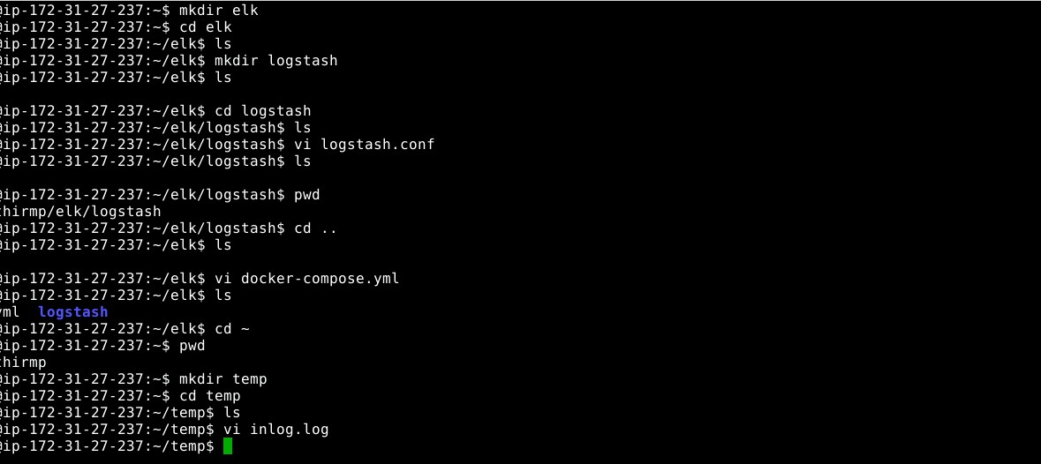

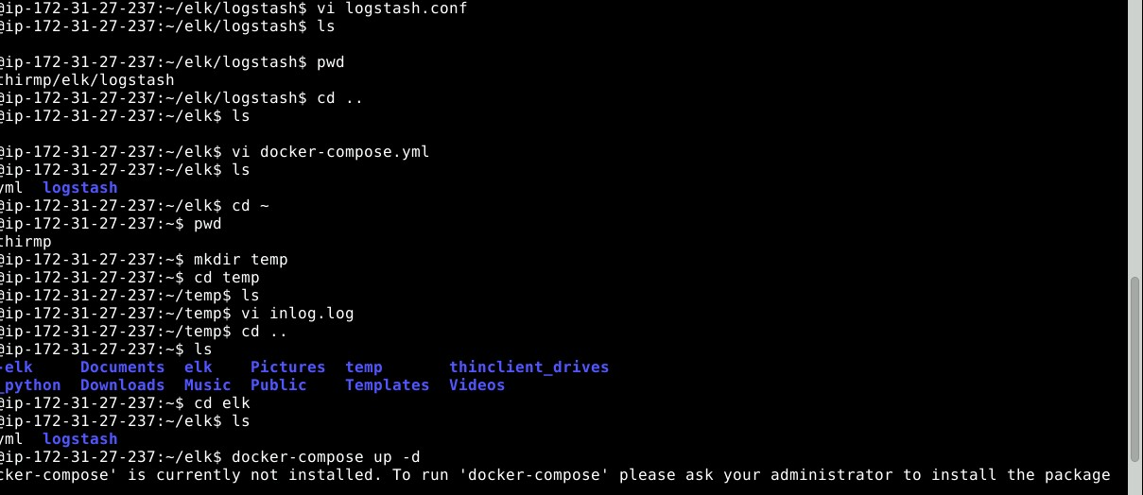

1. Installing ELK stack

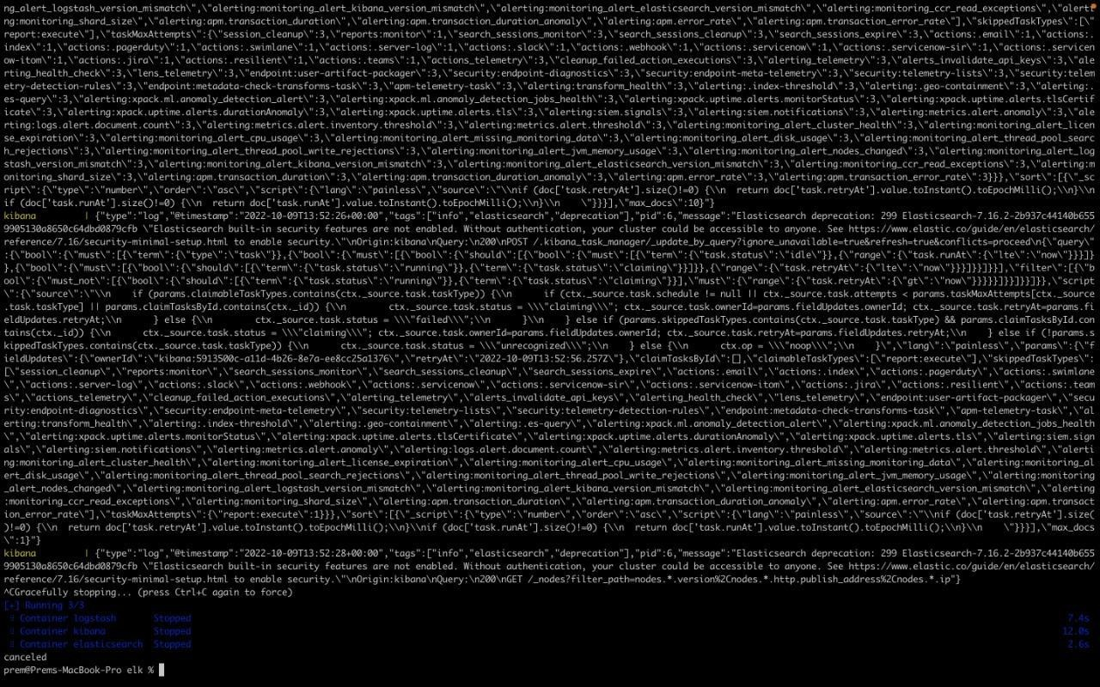

1. Run Localhost:5601 to connect with Elastic:

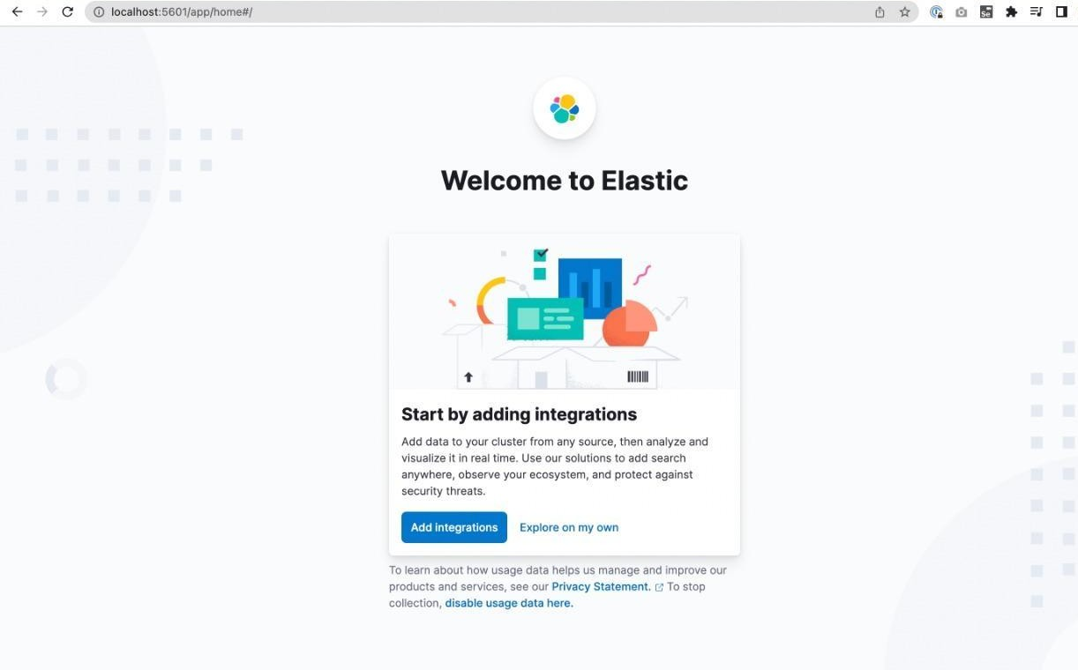

1. Explore the integrations:

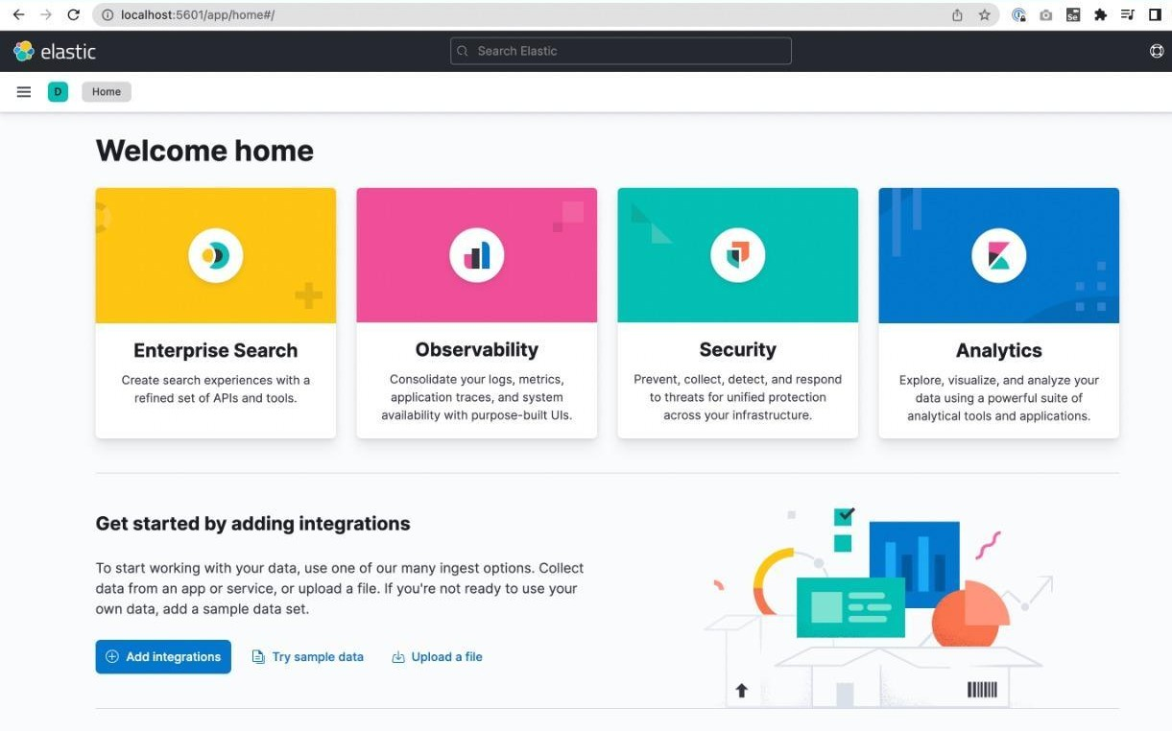

1. Index Management:

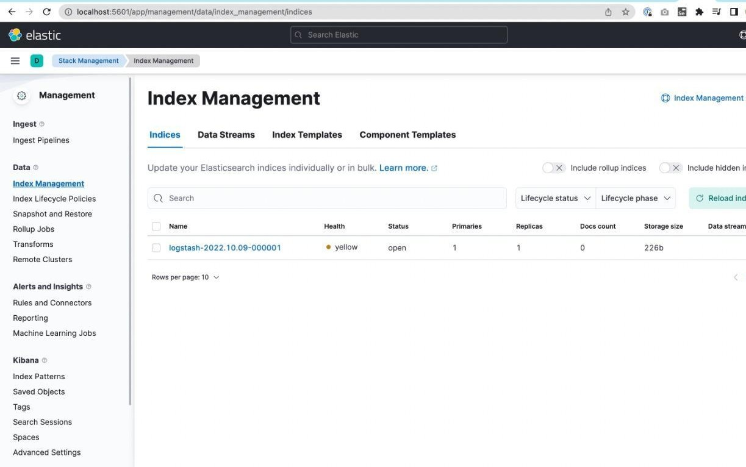

1. Check Status of log file:

